**The Lancet Series on Universal Health Coverage in Latin America**

**Date: Thursday 16 October 2014, 11:00 – 13:00**

**Moderated panel**

**Ines Bustillo, Director of the Washington Office of the United Nations Economic Commission for Latin America and the Caribbean, UN-ECLAC**

Inés Bustillo is the Director of the Washington Office of the United Nations Economic Commission for Latin America and the Caribbean (ECLAC). She joined ECLAC in 1989 as Economic Affairs Officer working on a variety of topics, including macroeconomic analysis, international trade and finance.

Previously, Bustillo was Professor of Economics at Universidad Anáhuac in Mexico City and Visiting Faculty at American University in Washington D.C. Other positions held include consultant to the World Bank, the Center for Latin American and Monetary Studies (CEMLA), and Operadora de Bolsa in Mexico City.

She is the author of several articles and a frequent lecturer at universities, think tanks, and other fora.

Bustillo, a national of Uruguay, earned her M.A. and Ph.D. degrees in economics from American University.

**Michael Myers, Managing Director, Rockefeller Foundation**

Michael Myers performs a number of leadership roles at The Rockefeller Foundation. He leads the Foundation's global health work including its [Transforming Health Systems](http://www.rockefellerfoundation.org/blog/launch-rockefeller-foundation" \t "_blank) initiative and the campaign for universal health coverage. He also coordinates strategies for the Foundation's work in the United States with a focus on building inclusive economies in cities.

Myers joined The Rockefeller Foundation in 2010 and led the organization's successful [centennial program](http://www.rockefellerfoundation.org/our-centennial" \t "_blank), which included an array of global activities to build on past successes and to help shape the Foundation's future direction.

Prior to coming to The Rockefeller Foundation, he served in leadership capacities in the United States Senate for much of his career, including chief counsel and staff director to the late Senator Edward M. Kennedy. He worked on a range of issues, including health care, employment, economic development, refugees, immigration, and education. Before his career in government, he worked on refugee and international humanitarian matters for non-governmental organizations and the United Nations High Commissioner for Refugees.

Myers holds both a bachelor's and a master's degree in political science from Columbia University.

**James Fitzgerald, Director of Health Systems and Services, PAHO/WHO**

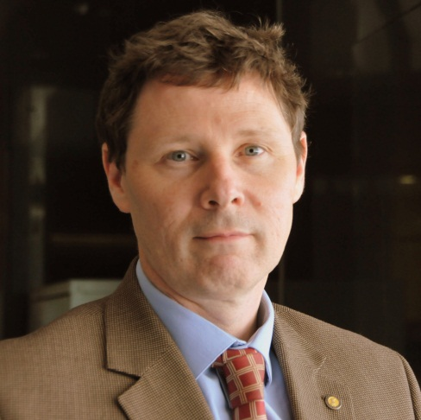Since 2014 James Fitzgerald is Director of Health Systems and Services, PAHO/WHO, overseeing the development of the regional Universal Health Coverage agenda with specific focus on health policy and governance, health systems and services organization, human resources for health, financing in health, and access to medicines and health technologies. Before that he coordinated PAHO regional work program in the Americas in Medicines and Health Technologies (2008 – 2013).

Fitzgerald is a national of Ireland, obtained his Bachelor in Science, Pharmacy and Ph.D. in Pharmaceutical Sciences from the University of Dublin, Ireland. Commencing his career in the pharmaceutical industry, he later joined the Pan American Health Organization / World Health Organization (PAHO/WHO) where he has worked as advisor in policy issues relating to access and regulation of  medicines and health technologies in Haiti, Brazil and PAHO headquarters, Washington DC USA.

**Ariel Frisancho, Past-Coordinator and National Directorate member, ForoSalud**

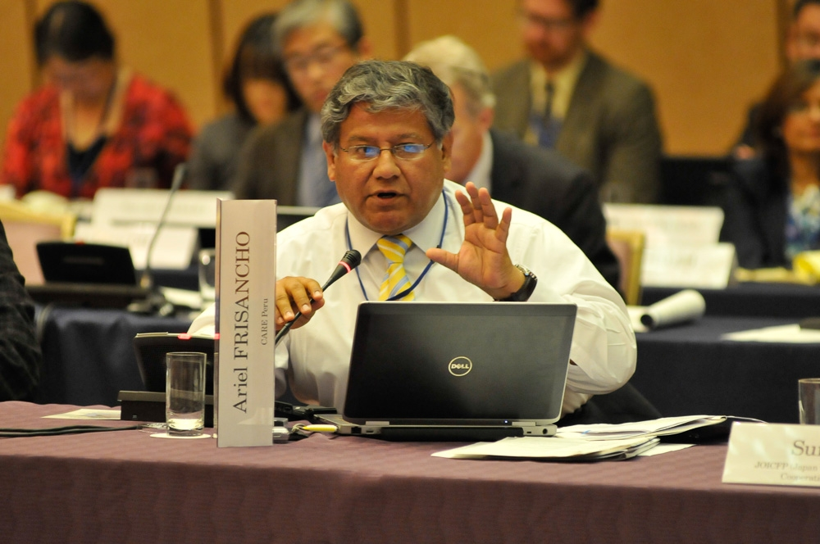Ariel Frisancho is Past-Coordinator and National Directorate member of ForoSalud in Peru. ForoSalud is a coalition of civil society organizations working in the health field since 2002. Foro Salud encourages citizen surveillance and the social control of public policies and services.

He has twenty five years of professional experience working in the Peruvian health International co-operation and social development sectors. He is a Consultant on Rights-based approaches, Citizen Participation, Health Governance and Accountability and author and co-author of chapters and articles on these issues at international publications.

In 2013 was selected as member of World Bank’s Civil Society Consultative Group for Health, Nutrition and Population. Lecturer on Health and Human Resources Policies at Peruvian Universities. He has been CARE Peru’s National Coordinator of the Social Rights Programs Unit, National Health Systems Adviser of Peruvian Movimiento Manuela Ramos (2001) and Executive Director of Peruvian Ministry of Health’s International Co-operation Office (1995-2000).

Frisancho holds a MSc degree from London School of Economics and Political Science / London School of Hygiene and Tropical Medicine on Health Policy, Planning and Financing.

**Richard Horton, Editor-in-Chief, The Lancet**

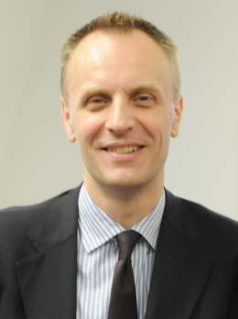Richard Horton is Editor-in-Chief of The Lancet. He is an honorary professor at the London School of Hygiene and Tropical Medicine, University College London, and the University of Oslo.

Horton joined The Lancet in 1990. He was the first President of the World Association of Medical Editors and he is a Past-President of the US Council of Science Editors. He is a Council member of both the UK’s Academy of Medical Sciences and the University of Birmingham and is a Senior Associate of the UK health-policy think-tank, the Nuffield Trust. In 2011, he was elected a Foreign Associate of the US Institute of Medicine.

He was born in London and is half Norwegian. He qualified in physiology and medicine from the University of Birmingham in 1986 and received honorary doctorates in medicine from the University of Birmingham, UK, and the University of Umea, Sweden.

**Jeanette Vega, Director of FONASA Chile**

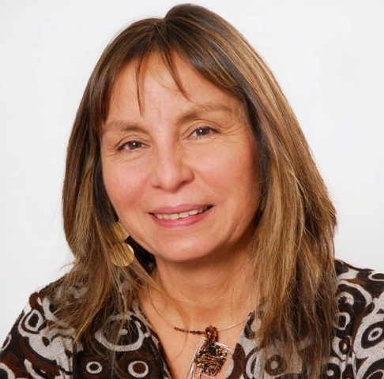Jeanette Vega recently joined FONASA (Chilean National Health Fund) as Director. FONASA provides health coverage to more than 13, 5 million people, without discrimination due to age, sex, income level, number of dependents or pre-existing conditions.

Before that Jeanette Vega was Managing Director at the Rockefeller Foundation where she lead the work in Health including development of strategy, implementation of the Foundation’s current Transforming Health Systems Initiative, and pursuit of new work in the field.

Before 2012, she served as Director of the of the Center of Public Health Policy at the Universidad del Desarrollo in Chile. Before that, she was Vice Minister of health in Chile, leading the country’s 13-step agenda for equity in health. In 2003, Vega served as a Director at the World Health Organization in Geneva, where she led the equity in health agenda, looking at the social determinants of health and health systems.

She started her career as a medical doctor in Chile specializing in Family Medicine and has a master’s degree in Public health from the Universidad de Chile and a Ph.D. in Public Health from the University of Illinois at Chicago.

**Tim Evans, Senior Director, Health Nutrition and Population Global Practice,**

**World Bank Group**

Tim Evans is the Senior Director for the Health, Nutrition and Population Global Practice at the World Bank Group and has been active in the international health arena for more than 20 years.

Before joining the World Bank he was the Dean of the James P. Grant School of Public Health of BRAC University in Bangladesh. Previously he served as Assistant Director General at the World Health Organization, heading the Evidence, Information, Research and Policy Clusters, where he oversaw the production of the annual World Health Report.

Evans has been a leader in advancing global health equity and health systems performance throughout his career, notably through his work with the Rockefeller Foundation and the Harvard School of Public Health and with his contributions to the development of innovative partnerships, including the Global Alliance on Vaccines and Immunization, INDEPTH and Health Metrics networks, the Global Health Workforce Alliance and the World Alliance for Patient Safety.

He earned his DPhil in agricultural economics at Oxford, and pursued medical and postgraduate studies at McMaster and Harvard Universities.

**Rifat Atun, Director of Global Health Systems Cluster, Harvard School of Public Health**

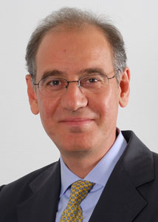Rifat Atun is Professor of Global Health Systems at Harvard University, and the Director of Global Health Systems Cluster at Harvard School of Public Health.

In 2006-13, he was Professor of International Health Management and Head of the Health Management Group at Imperial College London. In 2008-12 he served as a member of the Executive Management Team of The Global Fund to Fight AIDS, Tuberculosis and Malaria as the Director of Strategy, Performance and Evaluation Cluster.

His research focuses on the design and implementation of health systems reforms and their impact on outcomes. His research also explores adoption and diffusion of innovations in health systems (e.g. health technologies, disease control programmes, and primary healthcare reforms), and innovative financing in global health.

Atun has worked with several governments globally as well as the World Bank, World Health Organization, and the UK Department for International Development to design, implement and evaluate health system reform initiatives. He has led research and consultancy projects for GSK, Pfizer Inc., the Vodafone Group, Hofmann La Roche, PA Consulting, and Tata Consulting Services.

He studied medicine at University of London and subsequently completed his postgraduate medical studies and Masters in business administration at University of London and Imperial College London.

**Amanda Glassman, Director of Global Health Policy and Senior Fellow,**

**Center for Global Development**

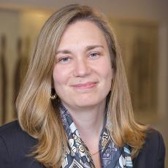Amanda Glassman is the director of global health policy and a senior fellow at the Center for Global Development, leading work on priority-setting, resource allocation and value for money in global health, with a particular interest in vaccination. She has 20 years of experience working on health and social protection policy and programs in Latin America and elsewhere in the developing world.

Prior to her current position, Glassman was principal technical lead for health at the Inter-American Development Bank, where she led health economics and financing knowledge products and policy dialogue with member countries, designed the results-based grant program Salud Mesoamerica 2015 and served as team leader for conditional cash transfer programs such as Mexico’s Oportunidades and Colombia’s Familias en Accion.

From 2005-2007, Glassman was deputy director of the Global Health Financing Initiative at Brookings and carried out policy research on aid effectiveness and domestic financing issues in the health sector in low-income countries.

Glassman holds a MSc from the Harvard School of Public Health and a BA from Brown University.

…………….

October 2014