**U.S. Government National Focal Point Manual**

*for*

**Notification of Potential Public Health Emergencies of International Concern**

*to*

**the World Health Organization**

*under*

**the International Health Regulations (2005)**

|  |  |
| --- | --- |
| **https://aspr.hhs.gov/communications/graphics/PublishingImages/HHS%20Logos/dhhs_logo%20reflex%20blue.png** | **https://aspr.hhs.gov/communications/graphics/PublishingImages/ASPR%20Logos/ASPR%20Logo%20small.jpg** |

International Health Regulations Program

Division of International Health Security - Office of Policy and Planning

Office of the Assistant Secretary for Preparedness and Response

United States Department of Health and Human Services

[hhs.ihrp@hhs.gov](mailto:hhs.ihrp@hhs.gov)

**SOP Created September 2012**

**Last Updated 29July2013**

**TABLE OF CONTENTS**

1. Purpose 3
2. Introduction 3
3. USG IHR Assessment and Notification Roles and Responsibilities 4
4. USG IHR Assessment and Notification Process 6
5. Protocol for Handling Personally Identifiable information 9

**Appendix**

* 1. IHR (2005) Decision Making Instrument 15
  2. USG IHR Event Assessment Form 17
  3. Event Assessment Example 20
  4. USG Participants in the Formal Review & Approval of Event Notifications 21
  5. Event Notification International Distribution List 25
  6. SOC Email to USG IHR Stakeholders - Template 26
  7. IHR Program Email to ASPR Leadership - Template 27
  8. IHR Program Email to Messaging Authority - Template 28
  9. SOC Notification Email to World Health Organization - Template 29
  10. SOC Event Update Email - Template 30

|  |
| --- |
| **This manual is an internal document of the United States Government and may not be shared outside of the United States Government without the consent of the IHR Program (**[**hhs.ihrp@hhs.gov**](mailto:hhs.ihrp@hhs.gov)**) within the Division of International Health Security, Office of Policy and Planning, Office of the Assistant Secretary for Preparedness and Response, Department of Health and Human Services.**  **This manual will be reviewed on an annual basis. In addition, all point of contact information will be updated on a bi-annual basis by the IHR Program.** |

# Purpose

This manual describes the U.S. Government (USG) process for notification to the World Health Organization (WHO) of public health events which may constitute public health emergencies of international concern (PHEIC) under the International Health Regulations (2005) [IHR (2005)][1] through the U.S. National IHR Focal Point (NFP).

# Introduction

The IHR (2005) are a legally-binding global health security framework agreed to by 195 States Parties[2], including all WHO Member States. The purpose and scope of the IHR (2005) are **“to prevent, protect against, control and provide a public health response to the international spread of disease in ways that are commensurate with and restricted to public health risks and which avoid unnecessary inference with international traffic and trade.”** The IHR (2005) represent a landmark approach to health security in today’s globalized world, where diseases and health threat agents have the potential to spread rapidly through expanded travel and trade. This updated set of regulations supports the development of national and international surveillance and response systems and requires all countries to notify WHO of any event, irrespective of origin or source and based on a risk assessment, which may constitute a PHEIC. A PHEIC is defined as an “extraordinary event [determined] to constitute a public health risk to other States through the international spread of disease and [that] potentially require[s] a coordinated international response.”

The IHR (2005) provide a decision-making instrument to help States Parties determine if an event meets the threshold for notification to WHO. This decision-making instrument is described in Annex 2 of the IHR (2005) and in Appendix 1 of this manual. **Under the IHR (2005), States Parties have 48 hours to assess an event that may represent a potential PHEIC once the national authorities become aware of this event, and 24 hours to notify WHO of the event, should the assessment indicate that notification is required.**

In order for States Parties to effectively comply with the notification requirements to WHO, the IHR (2005) require that each State Party designate a NFP to serve as a single point of contact with WHO for all IHR-related matters.

Under the IHR (2005), NFPs have four mandatory functions:

* Remain accessible at all times for communications with WHO IHR Contact Points;
* Send urgent IHR communications to WHO IHR Contact Points;
* Disseminate information to relevant national sectors, including those responsible for surveillance and reporting, points of entry, public health services, clinics and hospitals, and other government departments; and
* Consolidate input from relevant national sectors, including those responsible for surveillance and reporting, points of entry, public health services, clinics and hospitals, and other government departments.

This manual describes the structure of the U.S. NFP and the process for notification to WHO of public health events that may constitute a potential PHEIC through the U.S. NFP.

# USG IHR Assessment and Notification Roles and Responsibilities

In 2007, when the IHR (2005) entered into force in the United States, the USG developed, through an interagency consultation process, the mechanism that USG stakeholders would follow to comply with the IHR (2005) event notification requirements. The following section describes the steps to conduct **assessments** of public health events that may constitute a potential PHEIC and the **notification** to WHO through the U.S. NFP.

**Public Health Event Assessment**

*Editor’s Note*

*In the United States, the Secretary of HHS is equivalent to a Minister of Health. Although HHS takes the lead role in IHR matters, many other agencies in the U.S. play an active role as IHR stakeholders in reporting and assessing public health events.*

Since the IHR (2005) entered into force for the United States in 2007, the Department of Health and Human Services (HHS) was assigned as the coordinating agency on domestic IHR matters. HHS along with the Departments of Agriculture (USDA), and Defense (DOD), has had an active role in initiating assessments of events that may constitute a potential PHEIC. However, many USG agencies, including the Departments of Interior, Labor, Homeland Security, Commerce, Energy, Justice, State, Transportation, Treasury and Veteran Affairs; the Executive Office of the President, the Environmental Protection Agency, the Nuclear Regulatory Commission, and the U.S. Postal Service, are also IHR (2005) stakeholders and have participated and/or may participate in an assessment process, as needed, depending on the nature and impact of the event. All USG stakeholders are responsible for:

* Establishing an internal process for identifying events and conducting assessments of relevant events that may constitute a potential PHEIC;
* Consolidating input about public health events from relevant national sectors, including those responsible for surveillance and reporting, points of entry, public health services, clinics and hospitals, and other government departments; and
* Communicating the results of the assessment to the U.S. NFP.

# Potential PHEIC Notification/USG National Focal Point

The U. S. NFP was established in 2007 in the Office of the Assistance Secretary for Preparedness and Response (ASPR) within HHS and has three functional components with specific roles and responsibilities:

* The Assistant Secretary for Preparedness and Response (the ASPR)
* International Health Regulations Program (IHR Program)
* Secretary’s Operations Center (SOC)

***The ASPR***

The ASPR serves as the Message Authorizing Official for all official IHR (2005) communications with WHO on behalf of the HHS Secretary and the USG, and has the ultimate responsibility to approve the assessments and authorize notification of a potential PHEIC to WHO. The Office of the ASPR was created under the Pandemic and All-Hazards Preparedness Act of 2006 (PAHPA)[3] to lead the nation in preventing, preparing for, and responding to the adverse health effects of public health emergencies and disasters.  ASPR focuses on preparedness planning and response; building federal emergency medical operational capabilities; countermeasures research, advance development and procurement; and grants to strengthen the capabilities of hospitals and health care systems in public health emergencies and medical disasters. ASPR provides leadership in international programs, initiatives, and polices that deal with public health and medical emergency preparedness and response

*Editor’s Note*

The Secretary of HHS has delegated the leadership of all public health and medical services support during a public health emergency to the ASPR. As a result, the ASPR—and not the Secretary—provides the final approval for communication of a potential PHEIC to WHO.

Under PAHPA, HHS is the lead agency under the National Response Framework (NRF)[4] for Emergency Support Function (ESF)-8[5]. In this role, HHS has ongoing responsibilities throughout the preparedness, response, and recovery phases of incident management. The Secretary of HHS delegates to ASPR the leadership role for all public health and medical services support during a public health emergency.

***IHR Program***

The IHR Program serves as advisor on IHR matters to the ASPR and HHS leadership and leads and coordinates the development of polices and protocols on IHR (2005) related matters for the USG. The IHR Program oversees all U.S. NFP activities including manages and coordinates the assessment, clearance of the decision to notify, and notification to WHO of public health events within the United States that may constitute a potential PHEIC, and oversight and guidance to the SOC in its role as the one of the three components of the U.S. NFP. The IHR Program is staffed with policy analysts who serve as IHR Action Officers that are responsible for fulfilling the IHR Program’s responsibilities to the U.S. NFP and that are available 24 hours per day, 7 days per week.

The IHR Program is located within the Division of International Health Security (DIHS), within the Office of Policy and Planning (OPP) in ASPR. DIHS provides leadership in international programs, initiatives, and polices that deal with public health and medical emergency preparedness and response. OPP advises HHS and ASPR leadership through policy options and strategic planning initiatives to support domestic and international public health emergency preparedness and response activities.

***SOC***

The SOC, on behalf of the United States , issues authorized potential PHEIC notifications to WHO and serves as the operational communication point for IHR (2005) matters both domestically and internationally, operating on a 24 hours per day, 7 days per week basis. The SOC also maintains records of all official IHR (2005) communications, per SOC’s standard procedures.

The SOC is located within the Office of Preparedness and Emergency Operations (OEM) in ASPR. OEM is responsible for developing operational plans, analytical products, and training exercises to ensure the preparedness of the Office, the Department, the Federal Government and the public to respond to and recover from domestic and international public health and medical threats and emergencies. The SOC serves as the focal point for synthesis of critical public health and medical information on behalf of the USG. During emergency situations, the Emergency Management Group (EMG), through the SOC, facilitates coordination of ESF-8, public health and medical responses for HHS by providing strategic level planning and operational/logistical oversight for the deployment of ESF-8 resources in the region. During international engagement efforts, the ASPR will coordinate the Departmental response on behalf of the Secretary through the EMG in the SOC. In such events, IHR Program will coordinate with all relevant parties, as needed, in support of the Departmental response. In addition, the EMG provides a vehicle to coordinate ESF-6 and Recovery missions, as well as assists in overseeing deployment of personnel, conference calls and other requirements.

The SOC maintains communications with the National Operations Center (NOC), the FEMA National Watch Center (NWC), and other operations centers as required to support the HHS mission.  The SOC is structurally aligned with the NOC during day-to-day operations and during times of activation, and is closely aligned with their alert and activation sequencing.

# USG IHR Assessment and Notification Process

The USG IHR (2005) event assessment and notification process has four steps (See Figure 1):

* Initial public health event assessment;
* Review of a potential PHEIC assessment;
* Approval of notification of a potential PHEIC to WHO; and
* Posting to the WHO IHR Event Information Site and event updates

**Initial Public Health Event Assessment**

When a USG agency receives information about a public health event that meets at least one of the four criteria specified in the decision making instrument within Annex 2 of the IHR (2005) (See Appendix 1 for Annex 2 of the IHR (2005)), it will conduct and complete a formal assessment within **48 hours** (See Appendix 3 for assessment example template). The assessment will be based on the following specific criteria:

* Is the public health impact of the event serious?
* Is the event unusual or unexpected?
* Is there a significant risk of international spread?
* Is there a significant risk of international travel or trade restrictions?

Once the assessment is complete, and **if** **two of the four criteria are met,** the USG agency will immediately submit a USG IHR Event Assessment Form to the SOC (See Appendix 2 for USG IHR Event Assessment Form).

Of special note, any event involving one or more cases of **smallpox**, **SARS**, **human influenza caused by a new subtype**, and **poliomyelitis due to wild type poliovirus**, is **always immediately reportable** to the U.S. NFP for subsequent notification to WHO[6].

**Review of a Potential PHEIC Assessment**

*Editor’s Note*

*All components of the U.S. NFP are involved in the IHR event and notification process to effectively assess and report urgent information both nationally and internationally. Ensuring timeliness, accuracy and transparency is key to being able to efficiently act in an event that may constitute a PHEIC.*

Once the SOC receives the completed USG IHR Event Assessment Form, it will submit it to the IHR Program (See Appendix 4/Table 2 for contact information) immediately. The IHR Action Officer will ensure that the USG IHR Event Assessment Form contains all the necessary information and will contact immediately the submitting agency for updates as necessary. Following the IHR Program’s request, the submitting agency will have **two hours** to provide additional information.

Then the IHR Action Officer will coordinate with the SOC to draft the Notification Message for the USG IHR Stakeholders (See Appendix 6 for template of email to USG IHR Stakeholders). The SOC will submit the drafted message along with the completed USG IHR Event Assessment Form for further review and consideration to the USG IHR Stakeholders (See Appendix 4/Table 3 for contact information). The IHR Action Officer will forward the email to the ASPR and Designees for their situational awareness notifying them that the review is taking place – no action is required (See Appendix 7 for email template and Appendix 4/Table 1 for contact information).

Following the SOC’s request, The USG IHR Stakeholders will have **two hours** to provide their input to the IHR Program via the SOC. As needed, the IHR Program will convene, via the SOC[7], a meeting with relevant USG IHR partners to address any issues or gaps related to the event assessment.

After the assessment review is concluded, the IHR Action Officer will submit the Notification Message, along with the completed USG IHR Event Assessment Form, to the ASPR for formal approval and authorize the notification of the potential PHEIC to WHO (See Appendix 8 for email template to the ASPR and Appendix 4/Table 1 for contact information).

Of note, if the IHR Program receives an IHR-related message from the SOC or the U.S. agency conducting the event assessment after 18:00 hours, the IHR Action Officer will resume its activities the following day at 06:00 hours while complying with the 24-hour notification to WHO requirements. This process and timelines will be modified and expedited if a more urgent notification is needed.

**Approval of Notification of a Potential PHEIC to WHO**

***Clearance Process***

Once the IHR Action Officer communicates with the ASPR, the ASPR will have **two hours** to approve the Notification Message and authorize the notification of a potential PHEIC to WHO (See Appendix 8 for email template to the ASPR). If the ASPR is unavailable to respond via email within the first hour, the IHR Action Officer will call the ASPR to seek approval. If the IHR Action Officer is still unable to gather a response from the ASPR after the established two hours and phone call, the IHR Action Officer will seek approval and authorization from the Principal Deputy Assistant Secretary for Preparedness and Response (PDASPR) via email and phone call. If the PDASPR is unavailable to respond within an additional **two hours**, the IHR Program will seek approval and authorization via email and phone call from the Director of OPP or the Director’s designated authority immediately (See Appendix 4/Table 1 for contact information). If the OPP Director or designee is unavailable to respond the IHR Program will seek approval and authorization via email and phone call from the Director of OEM or the Director’s designated authority immediately.

*Editor’s Note*

*The USG has defined a roster of key senior officials who have the authority to approve potential PHEIC notifications in the absence of the USG message authorizing official. Each official has been allocated two hours to respond to potential PHEIC notifications before the next official is contacted via email and phone.*

*The succession of Message Authorizing Officials is listed below:*

1. *The ASPR*
2. *The PDASPR*
3. *The Director of OPP*
4. *The Director of OEM*

Of note, if the IHR Action Officer sends an IHR-related message to the ASPR at 18:00 hours or after, the two-hour timeline requirement will start the following day at 06:00 hours while complying with the 24-hour notification to WHO requirements.

When the message is sent to the ASPR for clearance and approval, ASPR leadership and IHR Program will be included in the email for their situational awareness (See Appendix 4/ Table 1 & 2 for contact information).

***Notification Process***

Once the ASPR or designee approves the notification of a potential PHEIC to WHO[8], the IHR Action Officer will direct the SOC to immediately submit the final Notification Message, along with the USG IHR Event Assessment Form, to the Pan American Health Organization (PAHO), which is the WHO Regional Office for the Americas (See Appendix 9 for Notification email template). The SOC will ensure that PAHO has received the report via email. The SOC will also simultaneously notify WHO headquarters and the Western Pacific Regional Office of WHO (WPRO)[9], as well as the IHR NFPs of Canada and Mexico, as per trilateral agreements made under the Security and Prosperity Partnership of North America (SPP) in 2007 and ratified in 2012 in the North American Plan for Animal and Pandemic Influenza (NAPAPI)[10] under the North American Leaders Summit (NALS) (See Appendix 5 for international partners distribution list). Lastly, the SOC will forward the notification email to USG IHR Stakeholders for their situational awareness (See Appendix 4/Table 1 and 3 for complete USG IHR Stakeholder contact information list).

This will complete the final step for the United States in meeting its obligations under the IHR (2005) to notify WHO of any event that constitutes a potential PHEIC.

**Posting to the WHO IHR Event Information Site (EIS) and Event Updates**

***Posting to the WHO IHR EIS***

Following notification of a potential PHEIC, PAHO will seek, via the SOC, USG approval for the posting of this event on the WHO IHR EIS[11]. WHO will submit to the SOC a draft of the EIS posting message for review and approval. Once the SOC receives this message from WHO, it will submit it to the IHR Program for review and approval. For events that may require broad and substantial interagency coordination, review, and input, including events that may have a significant impact on national security, the IHR Action Officer may seek the approval of the ASPR or relevant USG IHR Stakeholders before submitting additional information to WHO via the SOC.

Once the EIS posting message has been approved, the IHR Action Officer, via the SOC, will submit to PAHO, WHO HQ, WPRO, Canada, Mexico and USG IHR Stakeholders (See Appendix 10 for email template).

***Event Updates***

Event updates may be proactively provided by the U.S. agency that conducted the event assessment or updates may be requested from that agency by the IHR Program via the SOC. When the IHR Program receives these updates, it will share them, via the SOC, with PAHO, WHO HQ, WPRO, Canada’s NFP, Mexico’ NFP and USG IHR Stakeholders.

In addition, the IHR Program, via the SOC, may receive requests from international or USG IHR Stakeholders for updates on other public health events. The IHR Action Officer, via the SOC, will contact the appropriate U.S. agency to request updates and then share, via the SOC, with PAHO, WHO HQ, WPRO, Canada’s NFP, Mexico’s NFP and USG IHR Stakeholders.

1. **Handling of Personally Identifiable Information (PII) by the U.S. NFP**

The SOC occasionally receives PII related to individual cases. As the IHR NFP, the SOC may receive PII from other nations and is required to transfer that information to the appropriate agencies. This document will provide guidance for the SOC on handling of PII within the SOC or for transferring that information within the USG. The SOC maintains its own internal Standard Operating Procedure (SOP) for handling PII.

Note: Although the Health Insurance Portability and Accountability Act of 1996 (HIPAA) regulations do not apply directly to the SOC, much of the health information we discuss may be covered by HIPAA at one point in time. To ensure an understanding of why HIPAA is not relevant to the SOC, an explanation is included here.

**USG Requirements**

In day-to-day operations, there is little need for the SOC to receive PII outside of the “Do Not Board” system, which has its own authorization through interagency agreements. As the IHR NFP, the SOC may need to receive information relating to contact tracing or case notification from other nations. Although it is not a daily occurrence, the SOC should still have SOPs for handling PII when it is received. This memo clarifies the US Federal regulations applying to the SOC for the handling of PII.

The generally intended definition of “Personally Identifiable Information” is taken from OMB guidance and means information, which can be used to distinguish or trace an individual’s identity, such as name, social security number, and biometric records, alone or when combined with other personal or identifying information, which is linked or linkable to a specific individual, such as a date or place of birth or mother’s maiden name. The Privacy and Security Rules of the HIPAA do not apply to the SOC, because it is not a health care provider, health plan, or health care clearinghouse that transmits any health information in electronic form in connection with standard transactions covered by the HIPAA regulations. Entities that are covered by the HIPAA regulation, could be violation with HIPAA by sending information directly to the SOC. In this case, information should be sent directly to the CDC, since it is not a violation of HIPAA for covered entities to send information to registered public health authorities.

For the purposes of the SOC and the IHR Program, the Privacy Act is the most applicable law. The Privacy Act of 1974 simply identifies “records” as “any item, collection, or grouping of information about an individual…” [5 USC § 552a(a)(4)]. The individuals who are protected by the Privacy Act are U.S. citizens or aliens who are lawfully admitted for permanent residence in the United States. Handling of PII at HHS may be governed by the Privacy Act of 1974 and clarified by associated sections of the Code of Federal Regulations Title 45, Part 5b. Application of the Privacy Act hinges on the definition of a “system of records”, which is a group of records about individuals, and the agency actually retrieves information from the system by the individual’s name or other personal identifier such as a social security number. Information transferred from CDC to the SOC stays within the Department of Health and Human Services, falling under section 552a(b)(1) of the Privacy Act, which allows disclosures within the Department when necessary to perform official duties.

**IHR (2005) Requirements**

The IHR (2005) defines ‘personal data’ as “any information relating to an identified or identifiable natural person” (*Article 1*). Article 45 of IHR 2005 further clarifies specific requirements for handling of PII, primarily that any information must be “kept confidential and processed anonymously as required by national law”. In addition, the IHR 2005 requires that PII is processed fairly and in accordance with national law, is relevant and not more than necessary for public health purposes, is accurate and up-to-date where necessary, and destroyed or erased as soon as the record is no longer necessary. WHO will also provide PII upon request of the individual, though it is unclear if they will provide WHO records or attempt to retrieve records from State Parties.

**U.S. NFP PII Management Considerations**

Neither the SOC nor the IHR Program have any need to keep a “system of records” of the information they receive, in a manner where information is actually retrieved by an individual’s name or personal identifier, so the Privacy Act will not apply to information received. In addition, the Privacy Act does not apply to individuals who are not U.S. citizens or aliens who are lawfully admitted for permanent residence in the United States, meaning that most information the SOC might receive under the IHR would not be covered regardless of its origin or use.

As long as the SOC does not maintain a “system of records” on individuals where by the SOC retrieves information by the individuals’ names or personal identifiers, and those individuals are either U.S. citizens or aliens lawfully admitted for permanent residence in the United States, there is no need to file a System of Records Notice. We do, however, need to ensure there is basic education on protocols for sending and receiving information to ensure that all PII and “records” are being received and handled appropriately.

HIPAA Privacy Rule and Public Health: Guidance from CDC and the U.S. Department of Health and Human Services. MMWR. 52(Supp.): May 2, 2003.

**PII Management Protocol**

**For all contact tracing** situations where the SOC receives information via emails/fax/mail or other ways of communications that include personal identifiable information (PII)[12], meant to support the USG in tracking individuals who may have been exposed to infectious diseases, the SOC must extract or protect, either by encryption or password protection, all the PII information, prior to sending it to the appropriate USG department or agency.

The SOC will destroy the fax/mail after confirmation that it has been successfully scanned, emailed to the SOC inbox, has been password protected. The destruction of original information includes emails.  Any email which is not password protected that we receive from another country, we need to immediately password protect, send it to the intended recipient, confirm receipt, and after that delete the original non-protected email.

If there are any concerns and/or questions the SOC should contact the IHR Program prior to submitting the information to a USG department or agency.

**For all other** PI related Information not covered under the guidance for contact tracing, the SOC **shall email** theIHRP Action officer on duty to request guidance for or confirm the routing of information to the appropriate USG department or agency. The SOC must ensure that any PII is encrypted or password protected.

The SOC Always send PII to the relevant USG department or agency in two parts

Original email[13]as a password protected email

Followed by a separate email that includes the password

The SOC always include the IHR Program email ([hhs.ihrp@hhs.gov](mailto:hhs.ihrp@hhs.gov)) in the CC line when sending PII information.

**Do not** include the IHRP POC List email in messages containing PII as this list will send the PII to individual staff members emails and could potentially compromise information.

**Figure 1: USG IHR Event Assessment, Review and Notification Schematic**

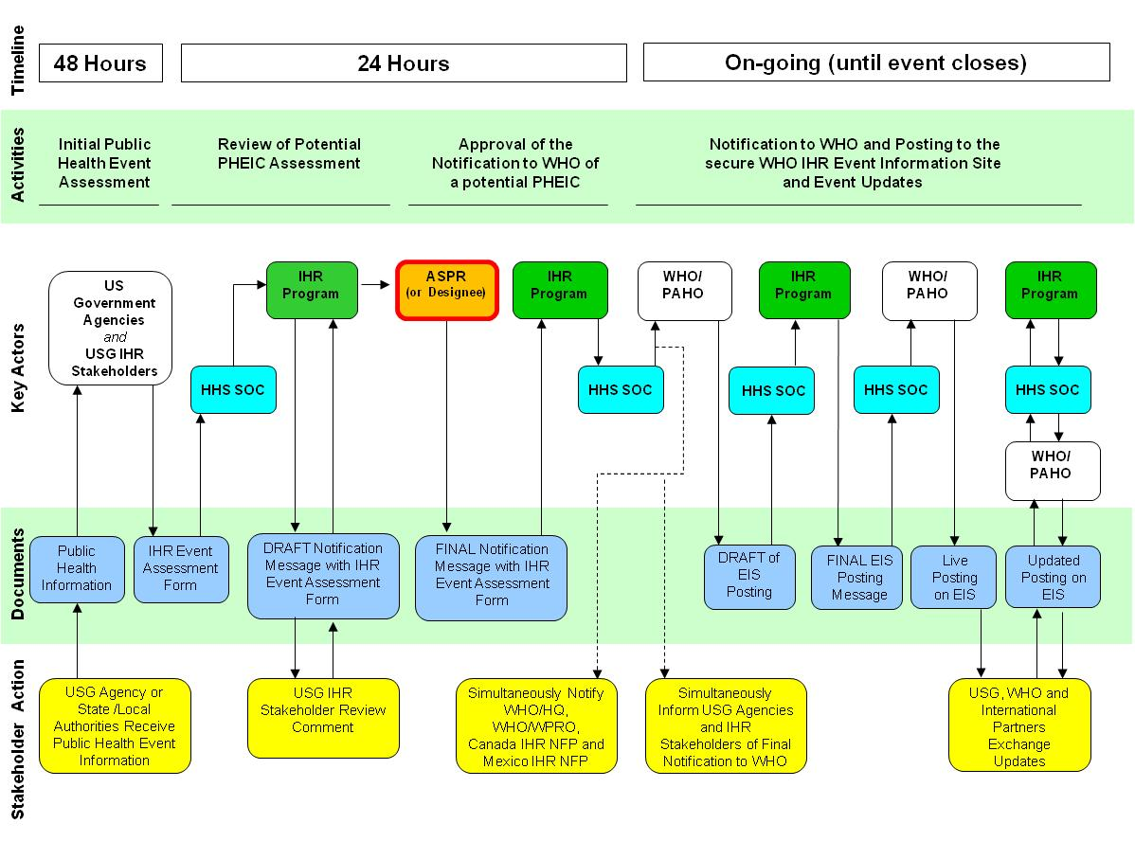

APPENDICES

**Appendix 1: Decision Making Instrument as described in Annex 2 of the IHR (2005)**

**Is there a significant risk of international travel or trade restrictions?**

**(See Criteria IV)**

**EVENT SHALL BE NOTIFIED TO WHO UNDER THE IHR**

**Events detected by national and international surveillance systems**

**Not notified at this stage. Reassess when more information becomes available**

**Is there a significant risk of international spread? (See Criteria III)**

**A case of the following diseases is unusual or unexpected and may have serious public health impact and thus shall be notified:\***

* **Smallpox**
* **Poliomyelitis due to wild-type poliovirus**
* **Human influenza caused by a new subtype**
* **Severe acute respiratory syndrome (SARS)**

***\*as defined by WHO***

**Any event of potential international public health concern, including those of unknown causes or sources and those involving other events or diseases than those listed in the box on the left and the box on the right shall lead to utilization of the algorithm**

**An event involving the following diseases shall always lead to utilization of the algorithm, because they have demonstrated the ability to cause serious public health impact and to spread rapidly internationally:\***

* **Cholera**
* **Pneumonic plague**
* **Yellow fever**
* **Viral haemorrhagic fevers (Ebola, Lassa, Marburg)**
* **West Nile**
* **Other diseases that are of special national or regional concern, e.g. Dengue fever, Rift Valley fever, and Meningococcal disease**

***\*These disease list shall be used only for the purposes of these regulations***

**Is the public health impact of the event serious?**

**(See Criteria I)**

**Is the event unusual or unexpected?**

**(See Criteria II)**

**Is the event unusual or unexpected?**

**(See Criteria II)**

**Is there a significant risk of international spread?**

**(See Criteria III)**

Re

**CDC**

* omment

Iden

**FDA**

* oncerns

evi

**S**

Questions

e call with relevant departments a**HHS**

**IHRP**

* Review/Approve Report
* Identify Concerns

nd agencies

n

**2)**

|  |
| --- |
| **DOES THE EVENT MEET AT LEAST TWO OF THE FOLLOWING CRITERIA?[14]**  **\*\* States Parties that answer “YES” to the question whether the event meets any two of the four criteria (I –IV) below, under Article 6 of the IHR shall notify WHO of the event of a potential PHEIC** |
| **Criteria I**  **IS THE PUBLIC HEALTH IMPACT OF THE EVENT SERIOUS?**  **The answer to criteria I is “Yes” if you answer “yes” to questions 1, 2, or 3 below**   1. **Is the number of cases and/or number of deaths for this type of event large for the given place, time or population?** 2. **Has the event the potential to have a high public health impact?**  * **The following examples of circumstances that contribute to thigh public health impact:** * **Event causes by a pathogen with high potential to cause epidemic (infectiousness of the agent, high case fatality, multiple transmission routes or healthy carrier)** * **Indication of treatment failure (new or emerging antibiotic resistance, vaccine failure, antidote resistance or failure)** * **Event presents a significant public health risk even if no or very few human cases have yet been identified** * **Cases reported among health staff** * **The population at risk is especially vulnerable (refugees, low level of immunization, children, elderly, low immunity, undernourished, etc)** * **Contaminant factors that may hinder or delay the public health response (natural catastrophes, armed conflicts, unfavorable weather conditions, multiple foci in the State Party)** * **Event in an area with high population density** * **Spread of toxic, infectious or otherwise hazardous materials that may be occurring naturally or otherwise that has contaminated or has the potential to contaminate a population and/or a large geographical area**  1. **Is the external assistance needed to detect, investigate response and control the current event, or prevent new cases?** |
| **Criteria II**  **IS THE EVENT UNUSUAL OR UNEXPECTED?**  **The answer to criteria II is “Yes” if you answer “yes” to questions 4 or 5 below**   1. **Is the event unusual?**  * **The following examples of unusual events:** * **The event is caused by an unknown agent or the source, vehicle, route of transmission is unusual or unknown** * **Evolution of cases more severe than expected (including morbidity or case-fatality) or with unusual symptoms** * **Occurrence of the event itself unusual for the area season or population**  1. **Is the event unexpected from a public health perspective?**  * **The following are examples of unexpected events:** * **Event caused by a disease/agent that had already been eliminated or eradicated from the State Party or not previously reported** |
| **Criteria III**  **IS THE THERE A SIGNIFICANT RISK OF INTERNATIONAL SPREAD?**  **The answer to criteria III is “Yes” if you answer “yes” to questions 6 or 7 below**   1. **Is there evidence of an epidemiological link to similar events in other States?** 2. **Is there any factor that should alert us to the potential for cross border movement of the agent, vehicle or host?**  * **The following are examples of circumstances that may predispose to international spread:** * **Where there is evidence of local spread, an index case (or other linked cases) with a history within the previous month of:** * **International travel for time equivalent to the incubation period (if the pathogen is known)** * **Participation in an international gathering (pilgrimage, sports events, conference, etc)** * **Close contact with an international traveler or a highly mobile population** * **Event caused by an environmental contamination that has the potential to spread across international borders** * **Event in an area of intense international traffic with limited capacity for sanitary control or environmental detection or decontamination** |
| **Criteria IV**  **IS THERE A SIGNIFICANT RISK OF INTERNATIONAL RESTRICTIONS?**  **The answer to criteria IV is “Yes” if you answer “yes” to questions 8, 9, 10 or 11 below**   1. **Have similar events in the past resulted in international restriction on trade and/or travel?** 2. **Is the source suspected or known to be a food product, water or any other goods that might be contaminated that has been exported/imported to/from other States?** 3. **Has the event occurred in association with an international gathering or in an area of intense international tourism?** 4. **Has the event caused request for more information by foreign officials or international media?** |

**Appendix 2: USG IHR Event Assessment Form**

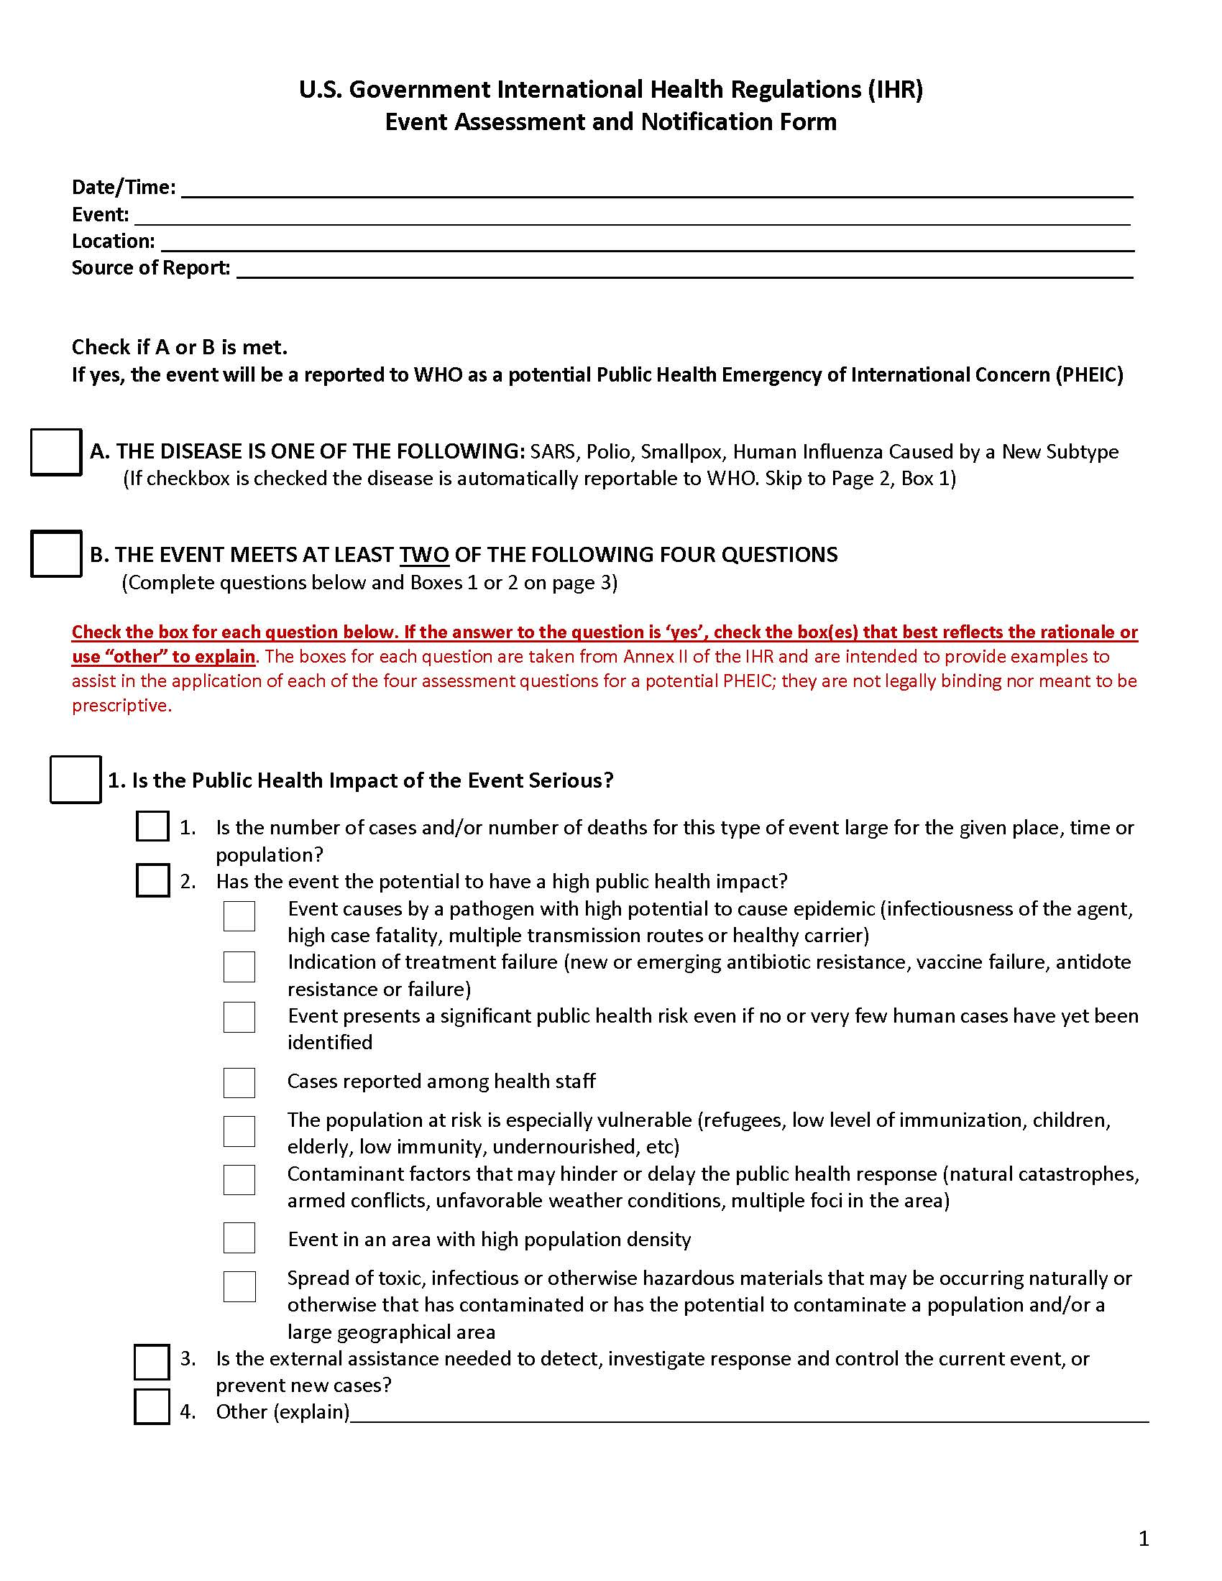

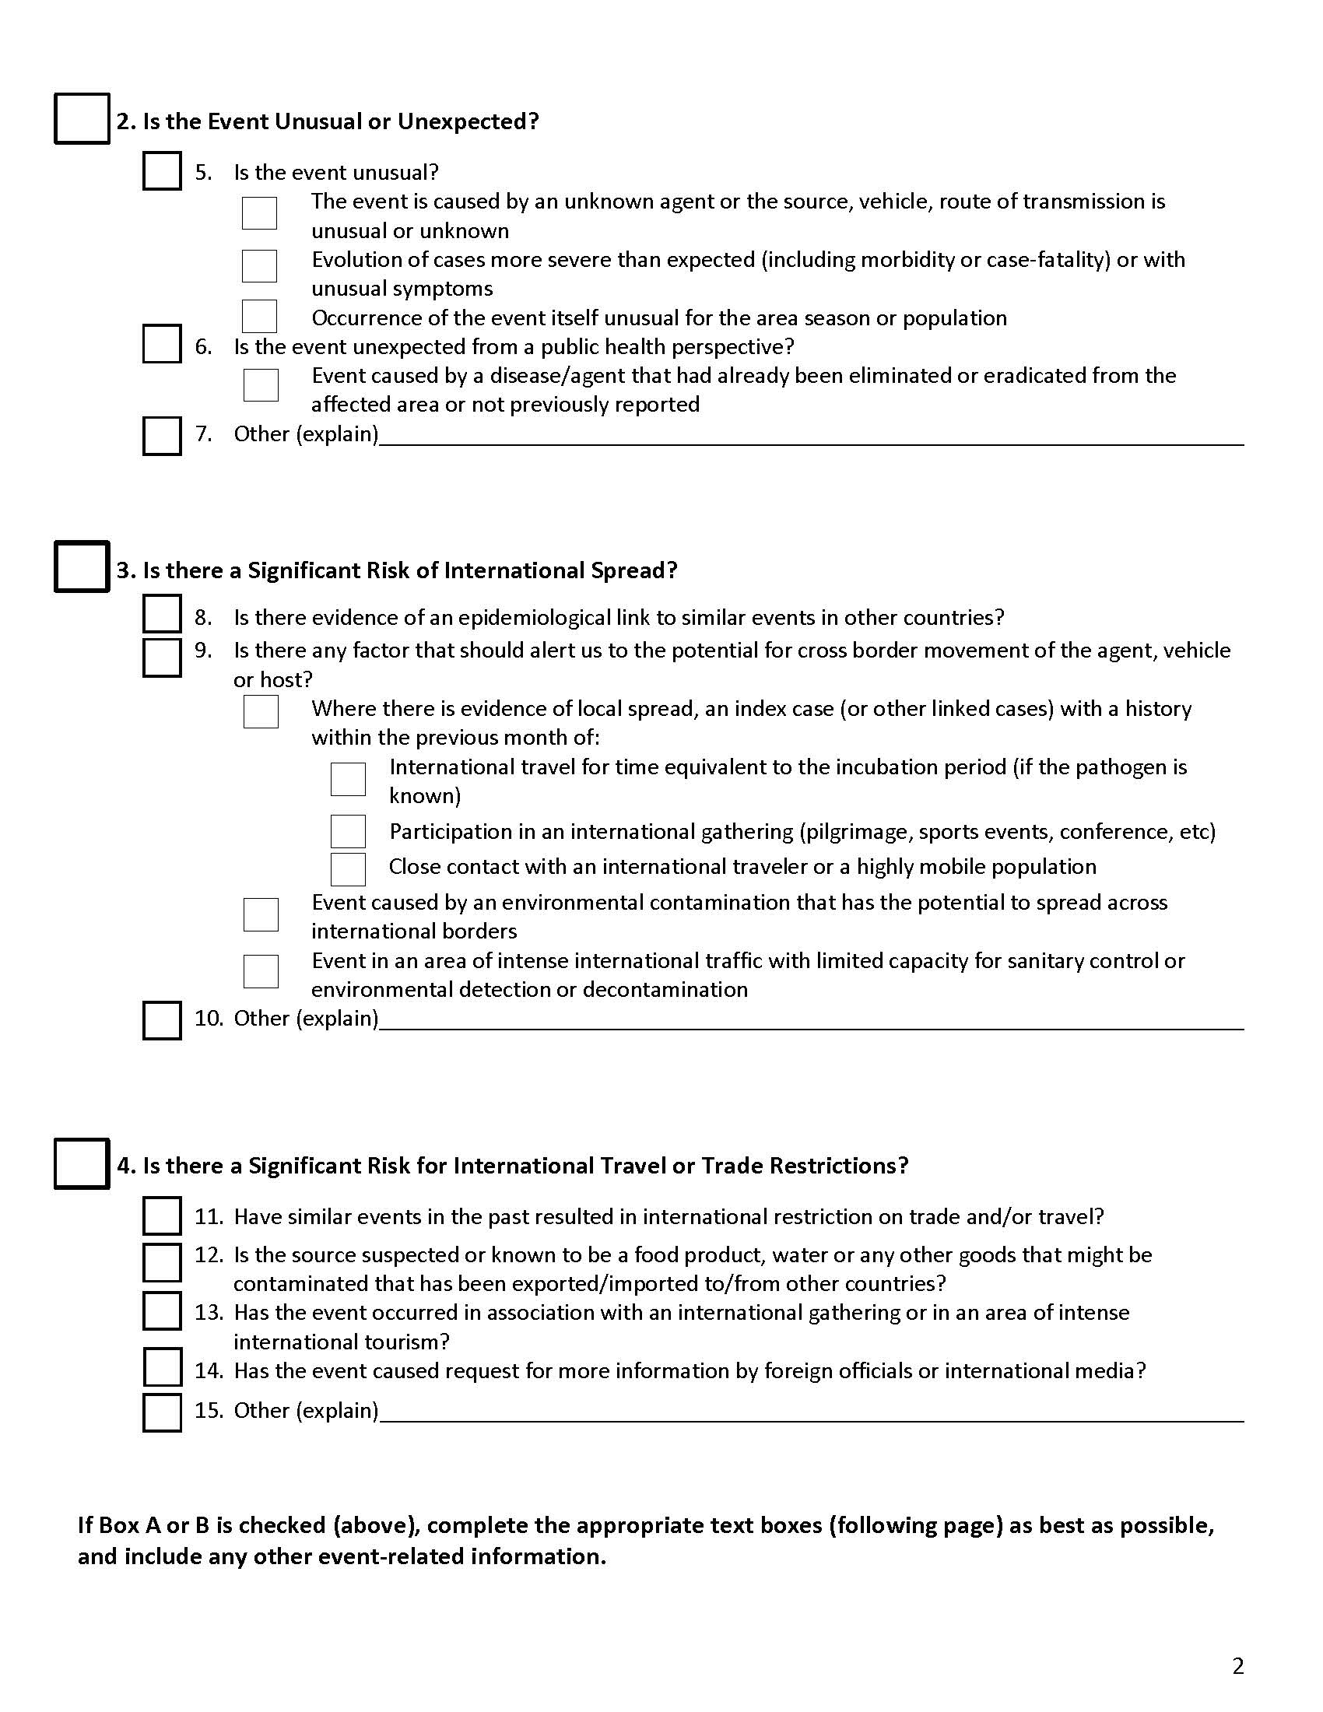

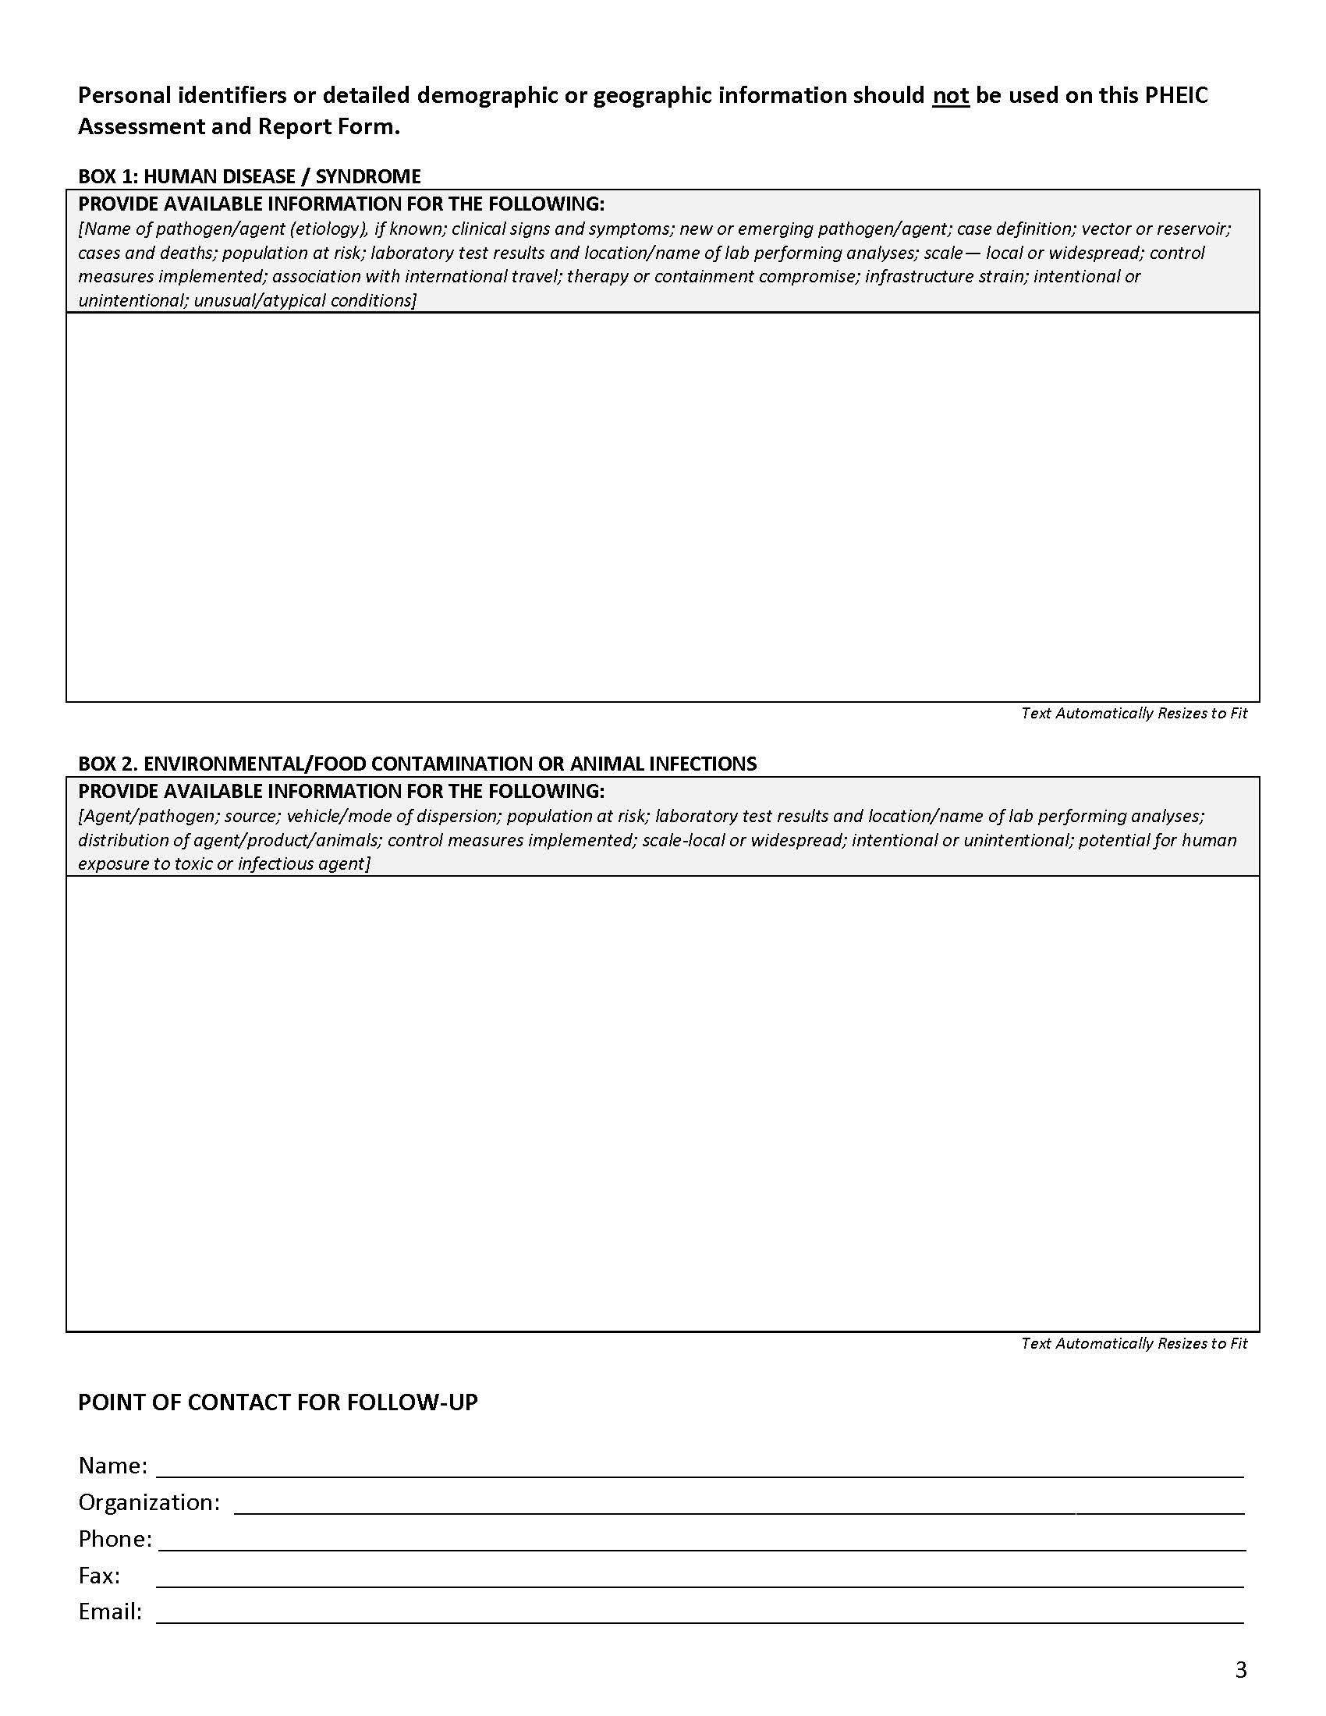

**Appendix 3: Event Assessment Model Example**

**U.S. Centers for Disease Control and Prevention Model**

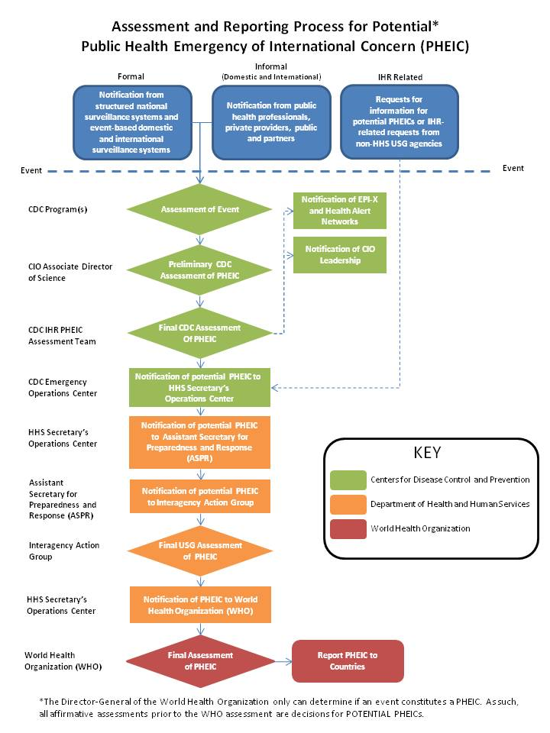

**Appendix 4: USG Participants in the Formal Review and Approval of Event Notifications**

**\*\* Maintained/Updated by the IHR Program, via the SOC.**

**Table 1: ASPR and Designees Contact Information**

|  |  |  |
| --- | --- | --- |
| **Organization** | **Participants** | **Email** |
| **HHS/ASPR** | Assistant Secretary |  |
| *Special Assistants for ASPR* |  |
| Principal Deputy Assistant Secretary |  |
| *Special Assistant for PDASPR* |  |
| Director of OPP |  |
| *Special Assistant for Director of OPP* |  |
| Deputy Director of OPP |  |
| Director of OEM |  |
| Deputy Director of OEM |  |
| Director of OPP/DIHS |  |
| Deputy Director of OPP/DIHS |  |

**Table 2: IHR Program Contact Information**

|  |  |  |  |  |
| --- | --- | --- | --- | --- |
| **IHR Program Contact List** | | | | |
| **Name** | **Email** | **Office #** | **BlackBerry #** | **Home #** |
| IHRP |  |  |  |  |
| IHRP POC [15] |  |  |  |  |
| Director DIHS |  |  |  |  |
| Deputy Director DIHS |  |  |  |  |
| IHR Branch Chief |  |  |  |  |
| IHR Program Manager |  |  |  |  |
| HHS Liaisons to Border Partners |  |  |  |  |
| Secretary’s Operations Center |  |  |  |  |

**Table 3: USG IHR Stakeholders**

|  |  |  |  |  |  |
| --- | --- | --- | --- | --- | --- |
| **USG Department**  **Agency** | **Office** | **Email address** |  | **Subject Matter Expert/IHR Related POC** | **Email address** |
| Central Intelligence Agency | Central Intelligence Agency |  |  |  |  |
| Department of Agriculture | Operation’s Center |  |  |  |  |
| Animal and Plant Health Inspection Service |  |
| Department of Commerce | N/A |  |  |  |  |
| Department of Defense | Joint Staff |  |  |  |  |
| National Guard Bureau Joint Operations Center |  |
| National Military Command Center |  |
| Joint Force Headquarters, National Capital Region |  |
| Pentagon Force Protection Agency |  |
| National Center for Medical Intelligence |  |
| Secretary of Defense Cables |  |
| Department of Energy | Office of Emergency Management |  |  |  |  |
| Department of Health and Human Services | Office of the Secretary |  |  |  |  |
| ASPR/IHR Program |  |
| Office of the Secretary |  |
| CDC Emergency Operations Center |  |
| CDC GDD Operations Center |  |
| CDC IHR functional mailbox |  |
| FDA |  |
| Health Resources and Services Administration |  |
| Office of Security and Strategic Information (OSSI) |  |
| Department of Homeland Security | National Operations Center |  |  |  |  |
| Transportation Security Administration |  |
| FEMA National Response Center HQ |  |
| National Communications System |  |
| Dept of Interior | Watch Office |  |  |  |  |
| Department of Justice | Justice Command Center |  |  |  |  |
| Federal Bureau of Investigation Strategic Intelligence Operations Center |  |
| Dept of Labor | Emergency Management Center |  |  |  |  |
| Department of State | Operations Center |  |  |  |  |
| Department of Treasury | Emergency Management Center |  |  |  |  |
| Department of Transportation | Crisis Management Center |  |  |  |  |
| Department of Veteran Affairs | VA Integrated Operations Center (VA IOC) |  |  |  |  |
| Environmental Protection Agency | Emergency Operations Center |  |  |  |  |
| National Geospatial-Intelligence Agency | NGA Operations Center |  |  |  |  |
| National Security Agency | Security Operations Center |  |  |  |  |
| Nuclear Regulatory Commission | Operations Center |  |  |  |  |
| United States Postal Service | United States Postal Inspection Service |  |  |  |  |
| Office of the Director for National Intelligence | National Counter Terrorism Center (NCTC) |  |  |  |  |
| Other USG EOCs | TBD – based on the event |  |  |  |  |
| Executive Office of the President | White House Communications Office |  |  |  |  |
| Office of Management and Budget |  |
| Domestic Policy Council |  |
| National Security Staff |  |
| Other USG D/A/ Command Centers | TBD |  |  |  |  |

**Appendix 5: Event Notification International Distribution List**

**\*\* Maintained/Updated by the IHR Program, via the SOC.**

|  |  |  |  |
| --- | --- | --- | --- |
|  | Organization | Email address | Telephone |
| TO: | WHO Headquarters |  |  |
| PAHO IHR Contact Point |  |  |
| CC: | WPRO IHR Contact Point |  |  |
| Canada NFP |  |  |
| Canada Points of Contact |  |  |
| Mexico NFP |  |  |
| Mexico Points of Contact |  |  |
| IHR Program Contact List |  |  |

**Appendix 6: SOC Email to USG IHR Stakeholders - Template**

**FROM:** The SOC

**TO line:** USG IHR Stakeholders (See Appendix 4/ Table 3 for contact information)

**\*\* DO NOT include the ASPR and Designee contacts (PDASPR, OPP and OEM Director and Deputy Directors) including Special Assistants listed in Appendix 4/Table 1. The IHR Program will notify these individual in a separate email using Appendix 7.**

**CC line**: IHR Program, IHR POC (See Appendix 4/ Table 2 for contact information)

**SUBJECT: URGENT IHR REVIEW REQUIRED: Potential PHEIC - (*Insert event title and place)***

**ATTACH:** USG IHR Event Assessment Form and supporting documents that were submitted to the SOC/IHR Program by the US Department/Agency that performed the assessment of the event

Good Morning/Afternoon Colleagues (*addressed to USG IHR Stakeholders)*

Please advise in the next **two hours** if you have any questions or comments.

The HHS/ASPR International Health Regulations (IHR) Program requests your review of the attached pending notification of a potential public health emergency of international concern (PHEIC).  Subsequent to this review period, we will request the approval of the Assistant Secretary for Preparedness and Response, who serves as the IHR Message Authorizing Official, to send this notification to the World Health Organization.

**Event information**

The IHR Program has been notified of a potential PHEIC involving (*insert couple of sentences summary here).*

**Title: XXXXX**

**Location**: XX, U.S.

**PHEIC notification criteria met:** (*Insert Criteria met)*

*(Summarize the event below; usually it involves copying and pasting the details from the IHR Notification form submitted by the US Department/Agency that performed the assessment of the event)*

Very Respectfully,

U.S. National IHR Focal Point

U.S. Department of Health and Human Services (HHS)

Assistant Secretary for Preparedness and Response (ASPR)

Secretary’s Operations Center (SOC)

200 Independence Ave S.W.

Washington D.C. 20201

WK: (202) 619 – 7800

Fax:  (202) 619 – 8602

Email: [hhs.soc@hhs.gov](mailto:hhs.soc@hhs.gov)

**Appendix 7: IHR Program Email to ASPR Leadership - Template**

Once the SOC sends the message to the USG IHR Stakeholders for their review and comment, the IHR Program will forward that email to the ASPR and ASPR leadership for their **situational awareness. No action is required from the ASPR or ASPR leadership.**

**FROM:** The IHR Program

**TO line:** The ASPR, PDASPR, Director and Deputy of OPP, Director and Deputy of OEM, Director and Deputy of DIHS, (See Appendix 4/Tables 1 and 2 for contact information)

**CC line**: IHR Program, IHR POC, Secretary’s Operations Center (See Appendix 4/ Table 2 for contact information)

**SUBJECT: FYSA: Processing a Potential PHEIC - (*Insert event title and place)***

Good Morning/Afternoon (*addressed to the ASPR or official designee),*

Please see below the message sent to USG IHR Stakeholders seeking their review of the potential PHEIC event. The IHR Program will seek your approval for transmission of the message to WHO, once USG IHR Stakeholders provide their comments. This message is for your situational awareness and no action is required.

Very Respectfully,

*On behalf of ASPR IHR Program*

*(IHR Program Action Officer full name)*

**Appendix 8: IHR Program Email to Messaging Authority –Template**

**FROM:** IHR Program

**TO line:** ASPR or Designee (See Appendix 4/ Table 1 for contact information)

**CC line**: PDASPR, Director and Deputy of OPP, Director and Deputy of OEM, Director and Deputy of DIHS, IHR Program; IHR POC, Secretary’s Operations Center (See Appendix 4/ Table 1 & 2 for contact information)

**SUBJECT: URGENT APPROVAL REQUIRED: Potential PHEIC - (*Insert event title and place)***

**ATTACH:** USG IHR Event Assessment Form and supporting documents that were submitted to the SOC/IHR Program by the US Department/Agency that performed the assessment of the event

Good Morning/Afternoon (*addressed to the ASPR)*

As the Message Authorizing Official for all official IHR communications with the World Health Organization (WHO), please advise in the next **two hours** if you have any revisions or questions and whether you authorize the transmission of the message to WHO.

IHR Program requires your review and approval of a potential public health emergency of international concern (PHEIC) notification to the WHO. In the event the IHR Program does make contact with you within the two-hour timeline, the IHR Program will seek Principle Deputy ASPR’s or his/her designee, approval and authorization to transmit the message to WHO.

Please note that this message needs to be transmitted to WHO by ***XX hour, Day, Month, Year***, This will be the ***XX***potential PHEIC notification for this year, ***(insert current year)*** and a total of ***XX* t**o date.

**Changes/Comments made during the USG IHR Stakeholder review period**: *(if any changes/comments were made, list them here if none state “none”)*

**Event information**

The IHR Program has been notified of a potential PHEIC involving (*insert couple of sentences summary here).*

**Potential PHEIC Notification Message to WHO:**(*insert drafted message)*

**Title: XXXXX**

**Location**: XX, U.S.

**PHEIC notification criteria met:** (*Insert Criteria met)*

*(Summarize the event below; usually it involves copying and pasting the details from the IHR Notification form submitted by the U.S. Department/Agency that performed the assessment of the event)*

Very Respectfully,

*On behalf of ASPR IHR Program*

*(IHR Program Action Officer full name)*

**Appendix 9: SOC Notification Email to WHO - Template**

**Part I:**

**FROM:** The SOC

**TO line:** WHO and PAHO IHR (See Appendix 5 for contact information)

**CC line:** Canada IHR, Mexico IHR, WPRO IHR, IHR Program POC (See Appendix 5 for contact information)

**Part II:**

**Then forward a copy of the email** to: USG IHR Stakeholders for their situational awareness (See Appendix 4/ Table 3 for contact information)

**SUBJECT: NOTIFICATION - United States - Potential PHEIC - (*Insert event title and place)***

**ATTACH:** USG IHR Event Assessment Form and supporting documents that were submitted to the SOC/IHR Program by the US Department/Agency that performed the assessment of the event

Dear WHO Colleagues:

Please see the attached the United States IHR Notification Form of a potential Public Health Emergency of International Concern (PHEIC) describing *(insert the title of the event and location).*

If the WHO decides that this event should be posted to the secure Event Information Site for National Focal Points, please let us know as we look forward to having the opportunity to preview and comment on the complete text of any proposed posting.

Very Respectfully,

U.S. National IHR Focal Point

U.S. Department of Health and Human Services (HHS)

Assistant Secretary for Preparedness and Response (ASPR)

Secretary’s Operations Center (SOC)

200 Independence Ave S.W.

Washington D.C. 20201

WK: (202) 619 – 7800

Fax:  (202) 619 – 8602

Email: [hhs.soc@hhs.gov](mailto:hhs.soc@hhs.gov)

**Appendix 10: SOC Event Update Email – Template**

**Part I:**

**FROM:** The SOC

**TO line:** WHO and PAHO IHR (See Appendix 5 for contact information)

**CC line:** Canada IHR, Mexico IHR, WPRO IHR, IHR Program POC (See Appendix 5 for contact information)

**Part II:**

**Then forward a copy of the email** **to**: USG IHR Stakeholders for their situational awareness (See Appendix 4/Table 3 for contact information)

**SUBJECT: EVENT UPDATE: United States *(Insert event title and place)***

**ATTACH:** Supporting Document/s *(if applicable)*

Dear WHO Colleagues:

Please see the attached update regarding the public health event (*insert event update title).[16]*

Please do not hesitate to contact us should you have any questions and/or concerns regarding this update.

Very Respectfully,

U.S. National IHR Focal Point

U.S. Department of Health and Human Services (HHS)

Assistant Secretary for Preparedness and Response (ASPR)

Secretary’s Operations Center (SOC)

200 Independence Ave S.W.

Washington D.C. 20201

WK: (202) 619 – 7800

Fax:  (202) 619 – 8602

Email: [hhs.soc@hhs.gov](mailto:hhs.soc@hhs.gov)

1. International Health Regulations (2005) - <http://www.who.int/ihr/en/>
2. A State Party is defined as a WHO Member State that has adopted the IHR (2005) and therefore contributes to the global legal framework for the detection of and response to international public health risks and potential PHEIC events.
3. <http://phe.gov/Preparedness/legal/pahpa/Pages/default.aspx>
4. <http://phe.gov/Preparedness/support/emergencypreparedness/Pages/default.aspx>
5. <http://phe.gov/Preparedness/support/esf8/Pages/default.aspx>
6. Under the IHR (2005)the occurrences of any of these diseases is considered unusual or unexpected and is likely to have a serious impact on public health and are always notifiable to WHO.
7. The IHR Program will provide all the necessary information to the SOC to successfully conduct the conference call.
8. WHO/PAHO will use the information received under Article 6 of the IHR (2005), for verification, assessment, and assistance purposes under the IHR (2005), and shall not make this information generally available to other States Parties, until such time as:

   The event is determined to constitute a PHEIC in accordance with Article 12 of the IHR (2005); or

   Information evidencing the international spread of the infection or contamination has been confirmed by WHO in accordance with established epidemiological principles; or

   There is evidence that:

   Control measures against the international spread are unlikely to succeed because of the nature of the contamination, disease agent, vector or reservoir; or

   The State Party lacks sufficient operational capacity to carry out necessary measures to prevent further spread of disease; or

   The nature and scope of the international movement of traveler, baggage, cargo, containers, conveyances, goods or postal parcels that maybe affected by the infection or contamination requires the immediate application of international control measures.
9. PAHO – because U.S. falls under this WHO regional office; WPRO because U.S. territories fall under this WHO regional office.
10. <http://www.phe.gov/Preparedness/international/Documents/napapi.pdf>
11. The WHO IHR Event Information Site (EIS) is a secure website developed by WHO to facilitate communications with the NFPs as part of the implementation of the IHR (2005). Information on the site is provided by WHO to all NFPs in confidence as specified in Article 11.1 of the IHR (2005). The U.S. has 5 access points to this site, two are held by HHS/ASPR (one with DIHS/IHR supervisor, one with OEM Director), two with CDC, and one with FDA. The SOC constantly monitors this site sending information and updates to the IHR Program for review and action, typically consisting of forwarding information to USG stakeholders for situational awareness and incorporation of information into reports for DIHS, ASPR and HHS leadership. <http://apps.who.int/csr/alertresponse/ihreventinfo/>.
12. Personal Identifiable information is defined as document (electronic or hard copy) that contain the following but not limited to: date, case, sex, location, addresses, numbers: passport , phone, social security or identification , license, patient, and any other information that could identify the patient
13. If it is in a fax form, please scan and follow the procedure for sending in a password protected email
14. The examples appearing in this Annex are not legally binding and are included only to assist in the interpretation of the decision instrument criteria.
15. IHRP POC includes all DIHS Staff
16. If the update is regarding an event that is posted on the EIS, please indicate that.

    Pan American Health Organization / World Health Organization. Multilateral IHR NFP Strengthening Workshop Toolkit. June. Washington, DC: PAHO/WHO; 2017