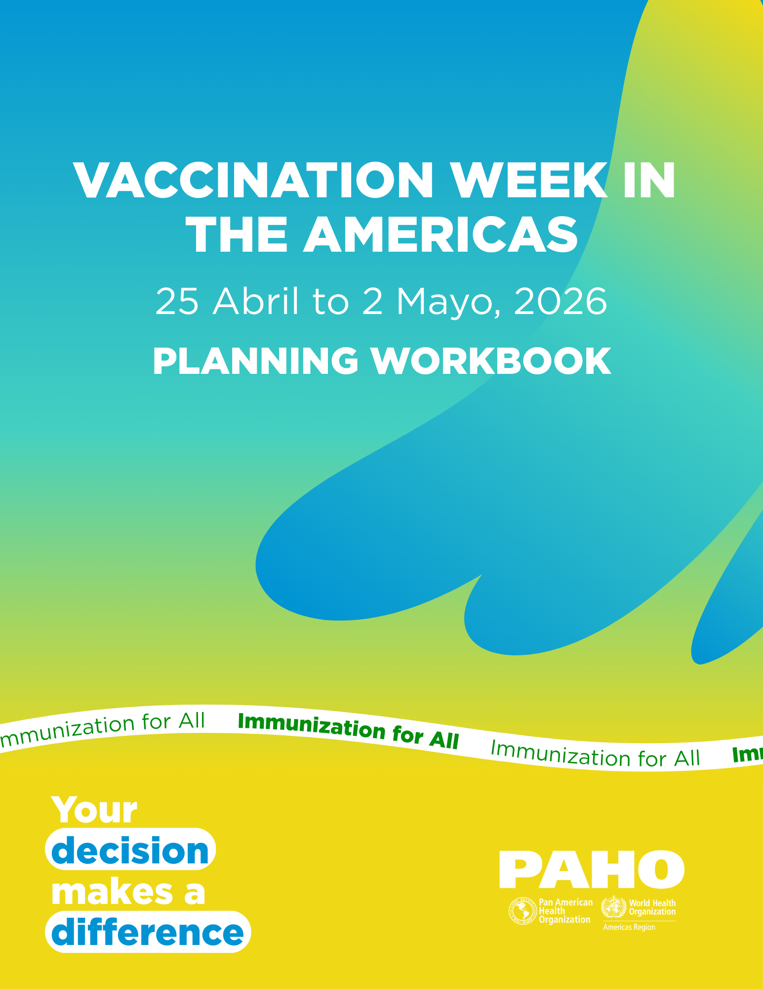

24ª Vaccination Week in the Americas (VWA)
25 April to 02 May, 2026

From April 25 to May 2, 2026, the Pan American Health Organization (PAHO), together with the countries and territories of the Region of the Americas and their partners, will celebrate the 24th Vaccination Week in the Americas (VWA) and the 15th World Immunization Week (WIW). This year's theme will focus on supporting countries' efforts to improve vaccination coverage and remain measles-free. The campaign slogan will be "Your decision makes a difference. Immunization for all."

Theme and direction
This year's Vaccination Week in the Americas (VWA) campaign will once again reinforce collaboration with PAHO's Elimination Initiative, highlighting vaccination as an essential strategy for achieving regional goals and avoiding critical setbacks, such as the loss of measles elimination re-verification. This poses a real threat to public health in the Region, making it urgent to close immunity gaps and prevent outbreaks in all countries of the Region.
Vaccination remains one of the most effective and safest interventions for protecting individual and collective health, and Vaccination Week in the Americas is considered a regional public good.
VWA will leverage its the platform to promote activities and messages that strengthen immunization against preventable diseases, with a special emphasis on measles, given the resurgence of cases, the risk of endemic transmission, and the contagiousness of the virus.
This call is even more relevant considering the upcoming global events in the Region like the 2026 World Cup, among others, which will attract millions of people to the Region from all over the world. International mobility increases the risk of imported measles cases, so ensuring consistent and high coverage in all countries is essential to protect populations and obtain re-verification of measles elimination in the Region of the Americas.
In addition, VWA will continue to focus on reducing the most urgent gaps according to each country's needs, ensuring that vaccination remains a political and social priority.
Specific objectives of the 2026 VWA
- Keep immunization at the top of the political agenda.
- Maintain elimination targets and control vaccine-preventable diseases, with a special focus on measles.
- Promote equitable access to vaccines throughout the life course and across communities in situation of vulnerability.
- Build confidence in the safety and efficacy of all vaccines.
- Provide evidence-based information to combat myths and misinformation about vaccines.
- Promote the spirit of Pan-Americanism.
- Position communities at the center of the communication strategy.
Key messages
Each year, PAHO uses this platform to promote access to vaccines and provide information about them.

This year's audiences will be:
- Determined by national priorities, as well as any other vaccine-preventable diseases that have been prioritized in the country.
- Have a special focus on health professionals as trusted sources of information among the public and as a priority population for vaccination strategies.

In addition, PAHO will develop and support the development of messages at two levels:

Regional level

As spokesperson for the Organization, PAHO’s Director Dr. Jarbas Barbosa will participate in the regional launch ceremony for the VWA in Canada on April 27, 2026. This ceremony will be an opportunity to obtain high-level political commitments from governments, partners, and donors to promote vaccination as an essential strategy for protecting the health of the population. To showcase regional commitment and Pan Americanism, there will be live connections to other countries that will be celebrating the Regional Launch.
Additionally, this will be the first year that Canada will be joining VWA as an active participant, representing a powerful opportunity to reaffirm its leadership in global health while advancing their national immunization goals.

Beyond strong support and visibility for national immunization programs, VWA aims to:
- Recognize the extraordinary public health achievements made possible by vaccines and the indispensable work required to maintain long-term elimination goals.
- Encourage continued support (financial and operational) for National Expanded Programs on Immunization (EPI) to protect people of all age groups throughout their lives, strengthening them to be prepared to respond to future pandemics and outbreaks.
- Strengthen the effective performance of surveillance operations for all vaccine-preventable diseases.
- Promote vaccines as safe and effective and respond to public concerns about the safety of vaccination products.
- Offer vaccination services at convenient times and locations.
- Recognize the achievements of health professionals and vaccination managers, who work hard every day to vaccinate as many people as possible, even in hard-to-reach places.
- Launch a communication campaign that supports countries in dispelling myths and misinformation about vaccines and that places communities at the center of communication strategies.
- Strengthen the communication capacity of primary health care professionals in relation to immunization, vaccines, and vaccination information.
- Promote the essential role that PAHO's Revolving Fund plays in countries to support them in obtaining affordable, high-quality vaccines and supplies for the program.

At the national level
Each country may select the combination of target populations, vaccine-preventable diseases, and locations on which to focus its own VWA activities. The selection should be based on the epidemiological situation and specific vaccination coverage gaps in each country.

Possible activities include:
- Reaching out to unvaccinated and under-vaccinated individuals, as well as areas with low vaccination coverage rates, to close the most urgent immunity gaps and reduce the pool of vulnerable individuals.
- Prioritizing the vaccination of children with no doses or incomplete schedules to close coverage gaps and protect them against dangerous diseases that threaten their future.
- Maintaining the elimination and control goals for vaccine-preventable diseases.
- Promote vaccination throughout the life course.
- Promote integrated health approaches such as vector control efforts, deworming for soil-transmitted helminthiasis, water, sanitation, and hygiene activities, handwashing, and deworming.

Beyond achieving high vaccination coverage rates, countries can use VWA events to:
- Build expectations and demand for vaccination by motivating people to get vaccinated and vaccinate their loved ones based on informed decisions.
- Increase the amount of reliable information available to the public about vaccine safety and efficacy, as well as the importance of vaccination in keeping communities protected.
- Use a variety of communication channels (print media, social media, collaborations with content creators, spokespersons, messages from government agencies and partners, paid advertisements) to reach the population, health professionals, and community leaders with tailored key messages about the VWA.
- Implement social listening activities to understand the sentiment and knowledge of the population regarding vaccines, vaccination, and immunization to develop more effective communication campaigns.
- Strengthen the collaboration with mass media and health-specialized journalists to provided evidence-based information to the public and help combat misinformation.
- Adapt vaccination services (e.g., increase vaccination sites, extend opening hours) to ensure that more people can access them.

Planning

To streamline both the planning and reporting of VWA campaigns and activities throughout the Region, PAHO has a standardized template for national plans and final country reports in Excel, the same as last year.

These templates are used to collect the minimum amount of information from all countries so that the PAHO Regional Office can compile the final VWA 2025 report. However, if the country wishes to provide additional information beyond what is requested in the template, we welcome this additional information in the form of annexes.

The plan and report have similar formats to facilitate the reporting process. The information requested is aligned with the objectives of the 2030 Agenda for Immunization and the PAHO Governing Bodies resolution "Strengthening Immunization Programs Strengthening Immunization as a Public Good for Universal Health".

Countries are requested to submit their national plans to the PAHO Regional Office by March 15, 2026 and final reports by May 31, 2026 so that this information can be consolidated and disseminated in timely manner.

Communication campaign

The concept of “decision” chosen for the campaign appeals to the individual and collective responsibility to get vaccinated, through a clear, familiar, easy-to-remember and positive message about the impact our decisions have, in this case, on public health. The campaign slogan is “Your decision makes a difference”.

All material related to the campaign will be available on the VWA website.

To support national adaptation and adoption, we will be sharing Canva Templates.

Make sure you have written permission from all persons appearing in photos or videos collected during the campaign to ensure their availability for future use (see Annex 7).

Social Media
- A social media package with messages will be developed.
- PAHO Director's message will be filmed and distributed online and on social media.
- Promotional video of the 2026 campaign
- Countries are encouraged to share photos on social media with the regional slogan and campaign hashtags.

Communication material
- VWA 2026 website in the four official languages
- Repository of previous campaign websites
- VWA 2025 Final Report and Website
- Regional Posters
- Banners
- Campaign promotional video in Spanish and English
- Video message from the PAHO Director in Spanish and English
- Package of materials for social media and activities in the four official languages
- Fact sheet with information for the press conference
- Brochure on national immunization schedules

Activities
- PAHO Regional Office press conference – TBD
- Press releases – Campaign launch and objectives
- High-level regional launch in Canada – April 27, 2026

World Immunization Week
- PAHO will try to align itself as much as possible with the message and direction of World Immunization Week (WIW).

Evaluation activities
It is important to periodically evaluate and adapt VWA activities to ensure that they are as effective as possible. This evaluation can help identify areas for improvement and help achieve objectives more efficiently. PAHO strongly encourages countries to undertake evaluation activities and report their results to the Regional Office. The evaluation methodology should be tailored to your specific set of activities. Examples might include a brief survey during VWA week to assess public confidence and satisfaction with vaccination, or a survey to assess the effectiveness of the VWA social communication campaign. Templates for these surveys are included in the Annexes section of this document and are available online.

Finally, countries are encouraged to develop their own assessment strategies. If necessary, PAHO can provide technical assistance for the development and application of these methodologies.

Annexes
- Annex 1: Tool for the National Plan (separate document)
- Annex 2: Final Report Tool (separate document)
- Annex 3: Reference List of VWA Indicators
- Annexes 4A and 4B: Sample survey to assess public confidence and satisfaction with childhood vaccination (4A) and adult vaccination (4B).
- Annex 5: Sample survey to evaluate 's social media campaign.
- Annex 6: Discussion guide on planning border activities
- Annex 7: Image release form

More planning material is available on our website.
Annex 3

Reference list of VWA indicators

Indicators for intensified vaccination in at-risk areas

- Number and percentage of children aged 1-4 years who received their first, second and third doses of DTP/Pentavalent (to measure the number of children with dose 0 who have been vaccinated during VWA, as well as the number of children with incomplete and completed schedules).
- Number and percentage of children aged 1 to 4 years who received the first, second and third doses of DTP/Pentavalent outside the recommended age interval (to measure the number of catch-up doses administered during VWA, as well as the number of children with incomplete and completed schedules).
- Number and percentage of women of childbearing age (MUF) who were vaccinated with the first dose of Td vaccine in municipalities at high risk of tetanus or pertussis outbreaks.
- Percentage of municipalities with plans for a second and third round of vaccinations to complete vaccination schedules after completion of VWA.
- Number of health workers who participated in VWA outreach activities.
- Number of indigenous and Afro-descendant population groups that received vaccination services during the VWA.

Vaccination indicators in high-risk municipalities

- Number of municipalities with coverage rate <50% for DTP1 that received vaccination services during VWA.
- Number of municipalities with coverage rate <50% for DTP3 that received vaccination services during VWA.
- Number of indigenous and Afro-descendant population groups living in at-risk municipalities that received vaccination services during the VWA.
- Number of at-risk border municipalities that participated in vaccination activities.

Indicators for specific extramural campaigns

- Percentage of municipalities in which a Rapid Coverage Check (RCC) was conducted and where measles/rubella, polio or diphtheria/tetanus/pertussis vaccination coverage was less than 95%.
Indicators for monitoring

- Number of suspected cases of measles/rubella and acute flaccid paralysis (AFP) that were identified through active search activities in the community and that had already been reported to the national surveillance system.
- Number of suspected cases of measles/rubella and acute flaccid paralysis (AFP) that were identified through active community search activities and had not been reported to the national surveillance system.

Policy priority indicators

- Number of representatives of government authorities (at international, national, regional or local level) who participated in VWA launching events.

Training indicators

- Number of forums, seminars or conferences on vaccines and immunization held during the VWA.
- Number of health workers who received training on vaccines and immunization during VWA.

Dissemination of information and media indicators

- Percentage of people interviewed in the selected areas who are aware of VWA events.
- Number of health workers who have received training on the objectives and goals of the VWA.
- Number of VWA television spots aired on national or local television stations.
- Number of VWA radio spots broadcast on national or local stations.
- Number of VWA promotional materials created and disseminated.
- Number of journalists informed about the objectives and advantages of the VWA.
- Number of VWA-related articles published in the national and local press.
- Number of VWA messages disseminated through official Ministry of Health channels (main website, EPI website, social media accounts, etc.).
- Number of people who participated in conversations about VWA through social networks.

Intersectoral/inter-institutional coordination indicators

- Number of inter-institutional meetings held by the VWA organizing committee.
- Number of agencies and/or organizations that participated in these meetings.

Integrated intervention indicators

- Number of integrated interventions performed during VWA (e.g., deworming, vitamin A supplementation, blood pressure checks, etc.).

Citizen satisfaction and confidence in vaccinations

- Number of people interviewed about their level of confidence in the safety and efficacy of vaccines.

Annex 4A

MODEL:

Survey to assess the population's confidence and satisfaction with childhood vaccinations

Interviewer Instructions: Interview people in the community (during rapid coverage monitoring activities, in markets, main squares, bus stops, on the street, etc.) who are the primary caregiver of at least one child under 5 years of age.
____________________________________________________________

On a scale of 1 to 5 (1 being "Strongly Disagree" and 5 being "Strongly Agree"), how would you rate the following statements?

1. Vaccinating my child is the right thing to do.

RANGE: ______________

2. Immunizations are important to keep children healthy.

RANGE: ______________

3. It is important to vaccinate my child to prevent the spread of disease in my community.

RANGE: _________________

4. I am satisfied with the immunization services my child receives at my local health center or clinic.

RANGE: _________________

5. As an adult, getting vaccinated is important to maintain good health.

RANGE: _________________

********

On a scale of 1 to 5 (1 meaning "not at all confident" and 5 meaning "very confident"), how confident are you in each of the following?

6. The safety of routine childhood vaccinations.

RANGE: _________________

7. Effectiveness of routine childhood vaccination.

RANGE: _________________

8. The benefits of routine childhood vaccination.

RANGE: _________________

Annex 4B

MODEL:

Survey to assess population confidence and satisfaction with adult vaccination

Interviewer Instructions: Interview ADULTS in the community (during rapid coverage follow-up activities, in markets, main squares, bus stops, on the street, etc.) who are between 18 and 90 years old.
____________________________________________________________

On a scale of 1 to 5 (1 being "Strongly Disagree" and 5 being "Strongly Agree"), how would you rate the following statements?

1. I know what immunizations I need to receive now that I am an adult.

RANGE: ______________

2. Immunizations are important to keep me healthy.

RANGE: ______________

3. It is important to get vaccinated to prevent the spread of disease in my community.

RANGE: _________________

4. I am satisfied with the immunization services I receive at my local health center or clinic.

RANGE: _________________

5. As an adult, getting vaccinated is the right thing to do.

RANGE: _________________
********

On a scale of 1 to 5 (1 meaning "not at all confident" and 5 meaning "very confident"), how confident are you in each of the following?

6. Safety of routine adult vaccinations.

RANGE: _________________

7. Effectiveness of routine adult vaccination.

RANGE: _________________

8. Benefits of routine adult vaccination.

RANGE: _________________

Annex 5

MODEL:

Survey to evaluate VWA's social communication campaign

Instructions to interviewer: Interview 1 in every 3-5 people you encounter in markets, main squares, bus stops, streets, etc. Make sure they are not health workers. It is recommended to avoid interviewing groups of people.
____________________________________________________________

Ask the following questions and mark the answers in the corresponding space:

- Which category does it belong to?

Category | Yes/No
Women of childbearing age (15-49)
Adult male (16-59)
Adult female (50-59)
Older adult - male (60 years and older)
Older adult - female (60 years and older)

If the person does not belong to any of these categories, stop the interview and exclude him/her from the analysis.

- Are you knowledgeable about vaccination?
Yes No

- Have you recently heard about any special vaccination activities?
Yes No

If the answer is "No", end the interview. If the answer is "Yes", continue.

- Can you tell me what type of immunization activity you have heard about? Check all that apply.

Vaccination activity | Yes/No
Vaccination campaign
Measles vaccination campaign
Rubella Vaccination Campaign
Influenza vaccination campaign
Polio Vaccination Campaign
COVID-19 Vaccination Campaign
Vaccination Week in the Americas
Other (specify)

- How did you hear about this activity? Check all that apply.
Source | Yes/No
Radio
Television
Speaker
Newspaper
School
Health center
Other (specify)

- When you heard about this vaccination activity, what did you do?
Action | Yes/No
I have checked my children's immunization records.
I got vaccinated
I took my child or someone else to get vaccinated.
Request more information
Other (specify)

Annex 6

DISCUSSION GUIDE

Planning of cross-border vaccination activities (if applicable)

- Identification of the municipalities on both sides of the border.
  - What is the vaccination coverage for the key antigens of the national immunization program in these municipalities?

  - Objectives of VWA activities in border municipalities. Select all that apply.
    - Vaccination services for unvaccinated and under-vaccinated persons
    - Vaccination services for specific groups
    - Planning three rounds of vaccination activities
    - Training of healthcare personnel in vaccines and immunization.
    - Cross-border supervision and control
    - Other, specify:

- Planning meetings
  - Place and date:
  - Responsible persons in each country:

- Social communication
  - Coordinated vs. separate campaigns
  - Languages
  - Cultural considerations
  - Media and communications
  - Use of surveys to evaluate the dissemination of information
  - Social listening activities
  - Community participation activities

- Resources
  - Budget and estimated costs
  - Resource mobilization plan

5. Other activities that can be included in the VWA framework

Annex 7

PHOTOGRAPHIC RELEASE FORM

Photographic, audio and video images release form

I hereby grant the rights to my image, likeness and/or sound of my voice, as recorded on audio or video tape or photograph, to the Pan American Health Organization/World Health Organization. I acknowledge that I assign these rights without expectation of payment or any other consideration and for an unlimited duration.

I understand that my image may be edited, copied, displayed, published or distributed and I waive the right to inspect the final product in which my image or voice appears. I further waive any right to royalties or other compensation derived from or related to the use of my likeness or voice. I also understand that this material may be used in a variety of educational settings and throughout a geographic area without restriction.

Photographic, sound or video recordings may be used for the following purposes:
  - Conference presentations
  - Presentations or educational courses
  - Informative presentations
  - Online training courses
  - Educational videos
  - Arts and publications for consultants

By signing this authorization, I understand that photographic or video recordings of me may be displayed electronically via the Internet or in the public educational environment, including, but not limited to, international videos.

I will be consulted about the use of the photographs or video recording for any purpose other than those listed above.

There is no time limit on the validity of this release and no geographic limitation on where these materials may be distributed.

This exemption applies only to photographic, sound or video recordings collected within the framework of the sessions listed in this document.

By signing this form, I acknowledge that I have read and fully understand the above disclaimer and agree to be bound by it. I hereby waive any claim against any person or organization using this material for the purposes and in the manner described herein.

Full Name___________________________________________________

Street Address/P.O. Box________________________________________

City ________________________________________________________

Prov./Postal Code/Zip Code______________________________________

Phone ___________________________ Fax _______________________

Email Address________________________________________________

Signature____________________________
Date____________________________

If this authorization is obtained from a person under 18 years of age, the signature of a parent or legal guardian is also required.

Signature of parent/legal guardian_____________________
Date: ___________

Countries should feel free to use additional indicators not included in this list if they are more relevant to national activities.
Adult immunization includes vaccines against diseases such as COVID-19, influenza, diphtheria, tetanus, hepatitis B, bacterial pneumococcus and yellow fever.

